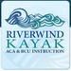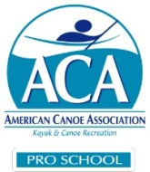
ACA Instructor Certification “Guest” Program
Here is a great opportunity for anyone who has always wondered about what’s involved in an instructor certification course. As a guest you can “sit in” on actual course for as many days as you like. This program will begin with our May L1-L2 Instructor Certification Workshops. There will be a limited amount of slots available for each course. Price is $45 per day. 50% credit should you decide to enroll in a future certification course.

